# Query Generator version 1.3.1 – What’s New?

Release Date: 02/01/2025 Author: Josh Swan

## New Features

* Removal of Christmas theme

## Bug Fixes

* SQL Table label was truncated on smaller screens.

Contents

Query Generator version 1.3.0 – What’s New? 1

New Features 1

Bug Fixes 1

FAQ 1

I want to use NOT on a single line, how do I do this? 1

My query isn’t returning the results that I am expecting 1

Do I still need to wrap my keywords in " for some columns? 2

I get a message telling me there’s an update 2

My computer is saying do I want to trust running this file? 2

Windows has blocked or refuses to run Query Generator 3

Why can I only select 10 different types of columns in my query? 3

Country Codes 3

# FAQ

## I want to use NOT on a single line, how do I do this?

In Query Generator, NOT is used as shorthand which is the same as how Beuth(our data supplier) represent the logic. In SQL however, sometimes we need to combine this with AND to make AND NOT. E.g.

**Title English:** (boat OR harbour) AND NOT plane

## My query isn’t returning the results that I am expecting

You might have found a bug but it is also likely something not quite right with your query or the search logic. Sometimes using more advanced search logic is better put into a single box with brackets than multiple column lines. For example, you might have a complex query like so:

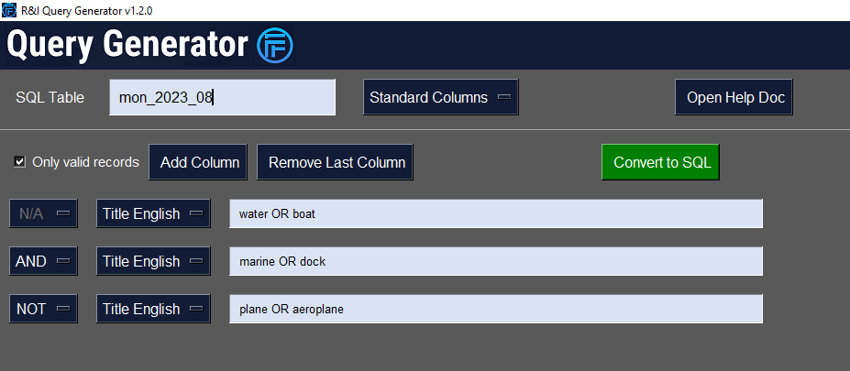

This can also be written as:

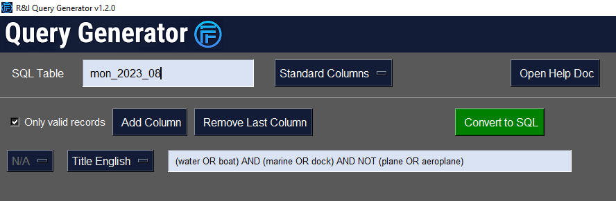

## Do I still need to wrap my keywords in " for some columns?

As of version 1.2.0 you are no longer required to use double quotes in wrapping your keywords as Query Generator will automatically do this for you, regardless of what column you are using. Simple!

## I get a message telling me there’s an update

Please follow the instructions on the Installation/Update guide that opens after the message regarding an update. If no file opens, please contact Josh.

## My computer is saying do I want to trust running this file?

This is a standard security response from Windows regarding some files like .exe, especially when downloaded from the internet. Josh has written this software internally and is safe to use, so you can ask Windows to trust to run the file. If there are any problems or concerns still, feel free to get in touch with Josh.

## Windows has blocked or refuses to run Query Generator

Please get in touch with Josh as this shouldn’t be happening.

## Why can I only select 10 different types of columns in my query?

Query Generator has been designed to use the most common columns for Domain Research and other research projects. More columns may be added if deemed necessary or some advanced SQL training can be delivered to help users customise the code output to suit their needs.

# Country Codes

**AT Austria**

**AU Australia**

**BR Brazil**

**CA Canada**

**CH Switzerland**

**CN China**

**CZ Czech Republic**

**DE Germany**

**DK Denmark**

**ES Spain**

**FA France standards**

**FI Finland**

**FR French regulations**

**GB Great Britain**

**IT Italy**

**IX European and international standards, European regulations**

**JO Jordan**

**JP Japan**

**KR Korea, Republic of**

**LT Lithuania**

**NL Netherlands**

**NO Norway**

**PL Poland**

**RU Russia**

**SE Sweden**

**SK Slovakia**

**TR Turkey**

**US United States**

**ZA South Africa**